POWER BI DASHBOARD ANALYSIS
Cybersecurity Log Analysis and Threat Detection

ORIGINAL DATASET DASHBOARD
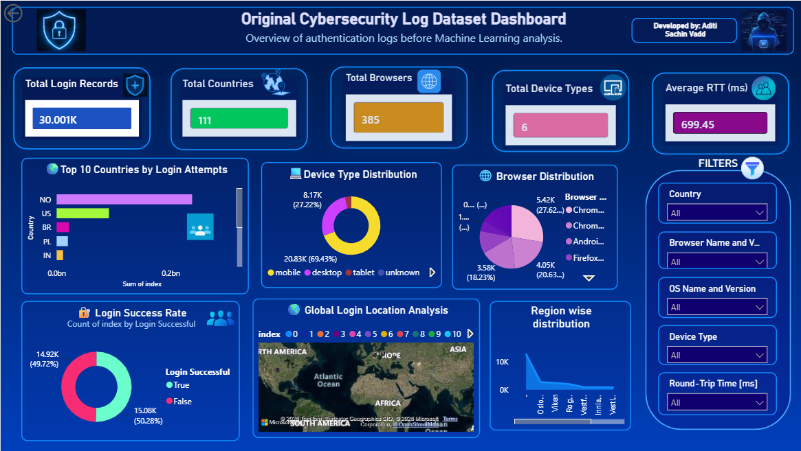
Login Activity & User Behavior Analysis

CYBERSECURITY LOG ANALYSIS DASHBOARD
Overview of Login Activity and User Behavior
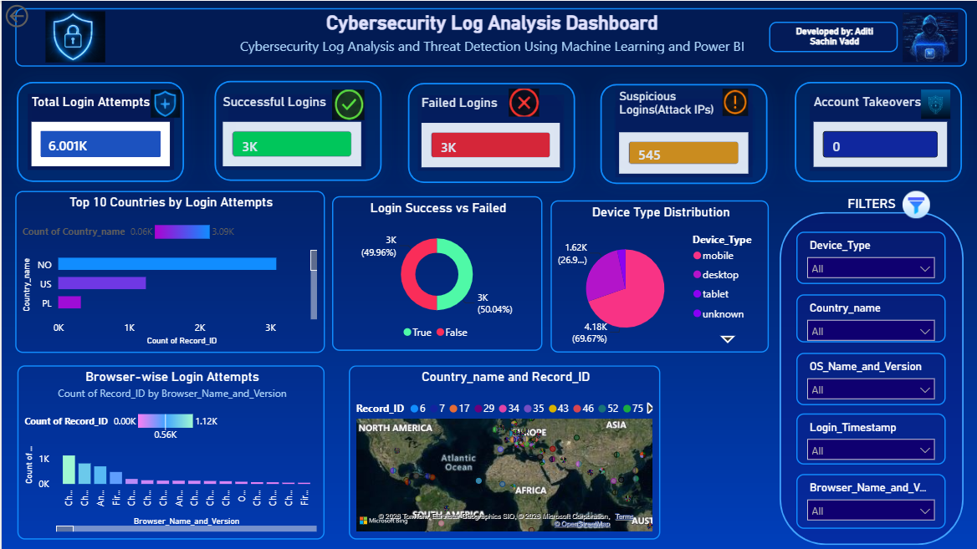
USER BEHAVIOR & ACCESS ANALYSIS
Detailed Analysis of User Login Patterns and Access Activity

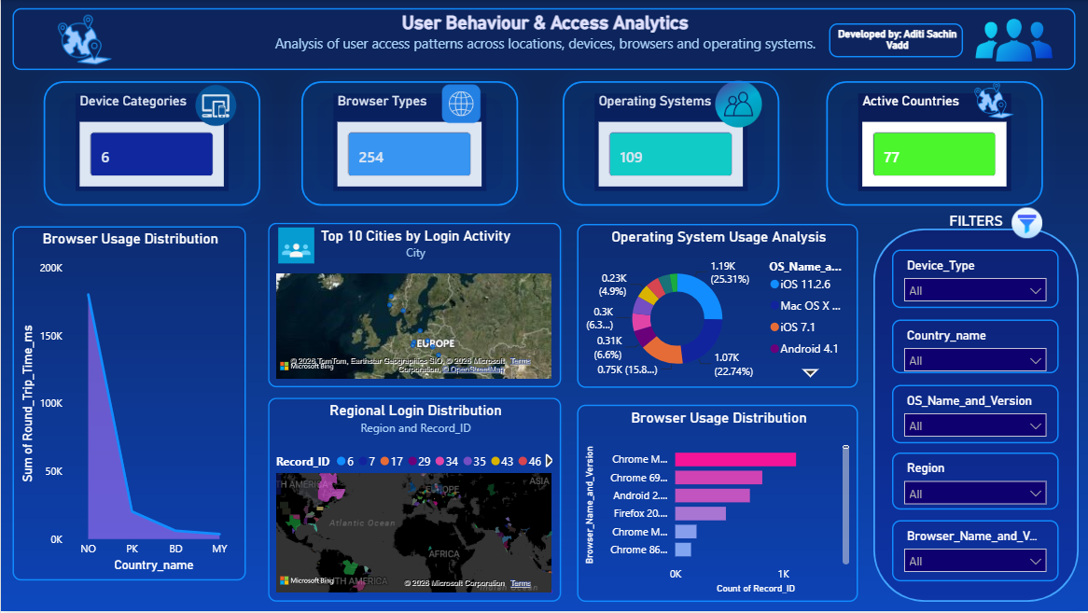
NETWORK & SECURITY INSIGHTS
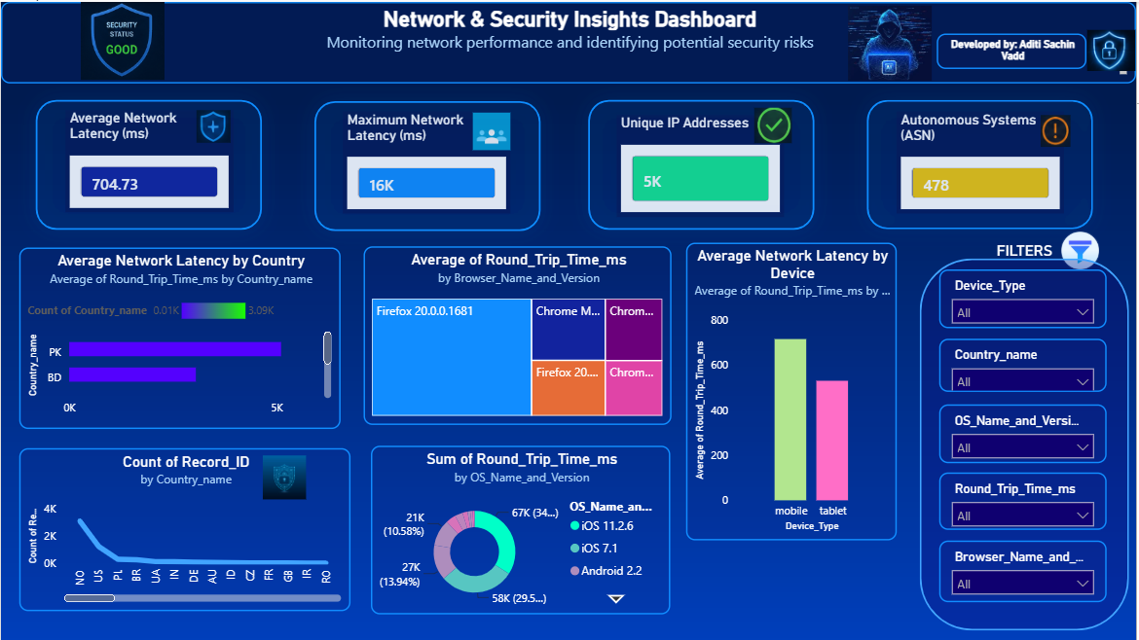
Analysis of Network Performance and Security-Related Login Patterns

